What I am looking for

Name of app
Math Mage
Devices (what devices support the app)
Any internet enabled device
Link (where to find the app)
https://www.touchdevelop.com/epppa
Type of app
Educational app
Target audience (who is this app aimed at):
Math Mage is aimed at a younger audience e.g. Primary school age.
App features
- 4 different games that teach children with their maths: Odd numbers, even numbers, prime numbers and multiplication.
- Colourful graphics.
- Fun/engaging sound effects.
- Varying levels of difficulty – easy, medium or hard.
- Designed for younger children – simple menus and navigation.

App strengths
It’s colourful, and very appealing to young children.
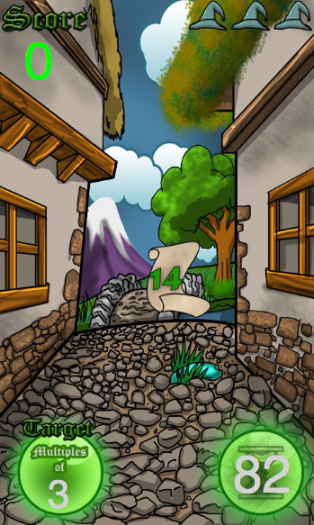
App weaknesses
Difficult to use if you’re not using a touch screen device.

