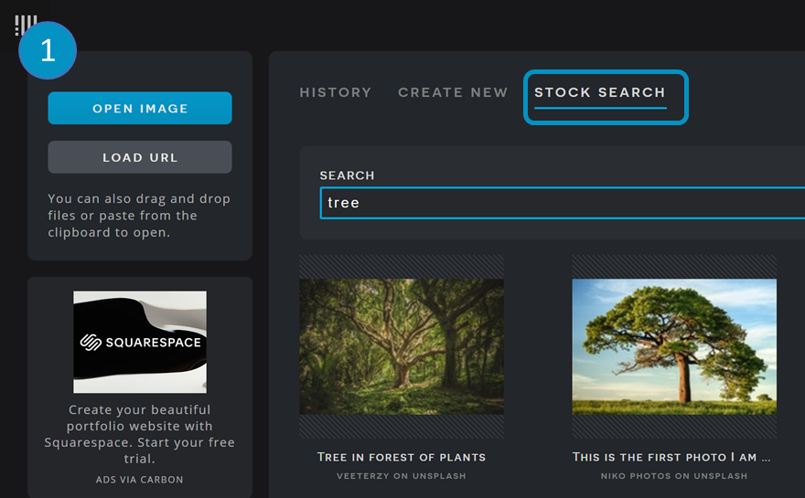  How to create a ‘Tree Octopus’ with Pixlr (Pixlr.com/x/) | 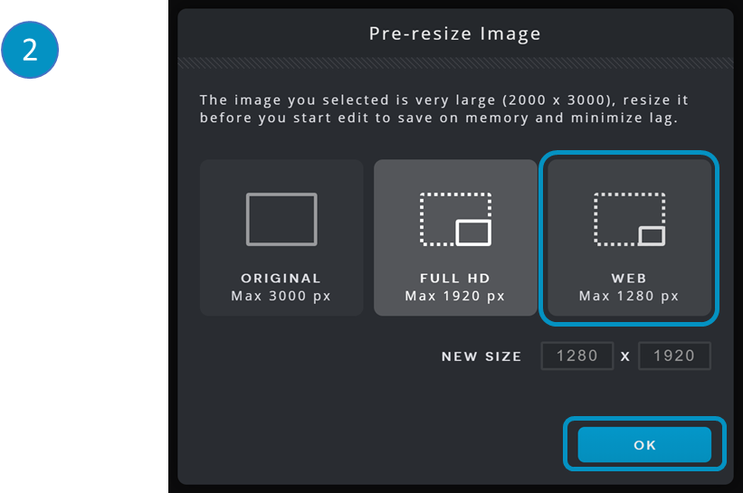
1. Search stock images for a tree. | 2. Choose an image size. Recommended: Web (max 1200 px).
 | 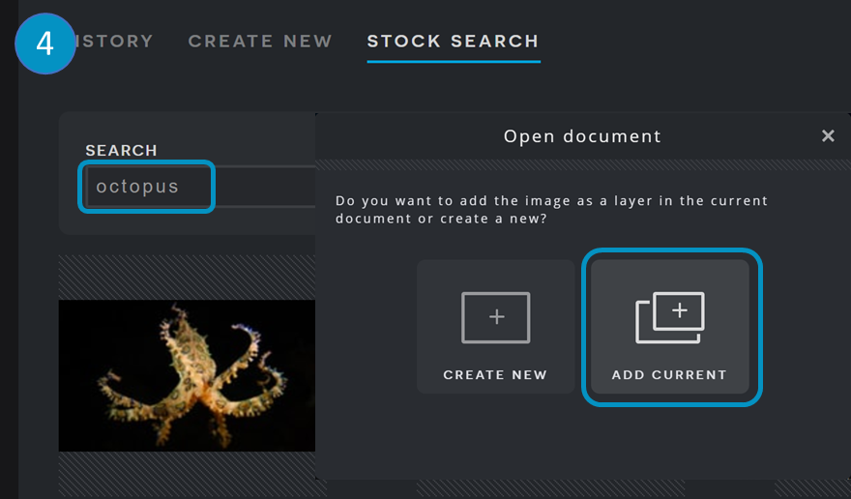
3. Click ‘Add Image’. Use ‘Browse’ to upload an image or ‘Stock’ to search. | Step 4. Choose your image overlay and click on ‘Add current’.
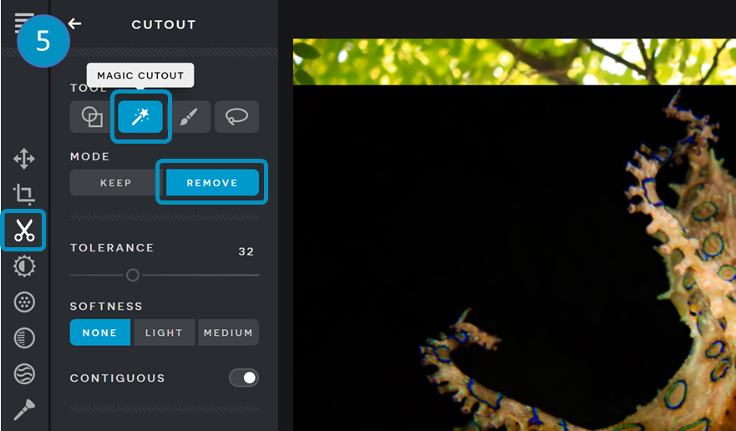  How to create a ‘Tree Octopus’ with Pixlr (Pixlr.com/x/) | 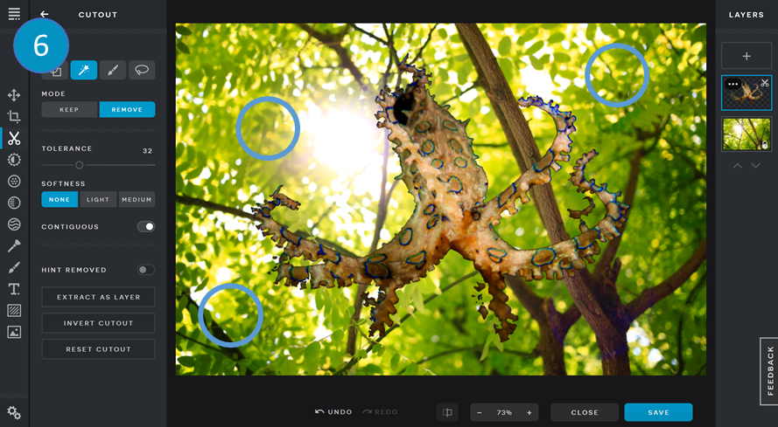
Step 5. Click on the ‘Cut’ tool. Select ‘Magic Cutout’ and ‘remove’. | Step 6.Click on the areas you wish to remove.
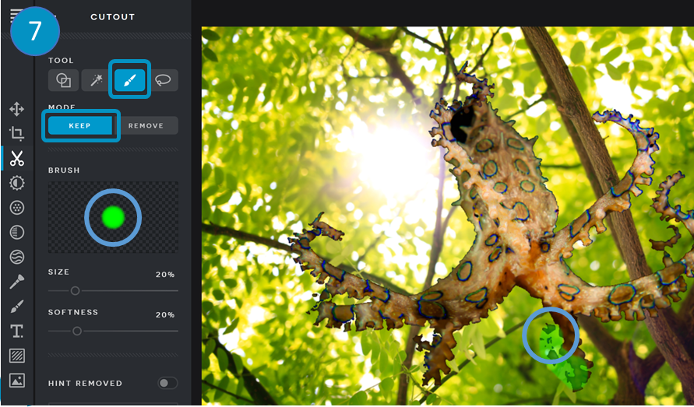 | 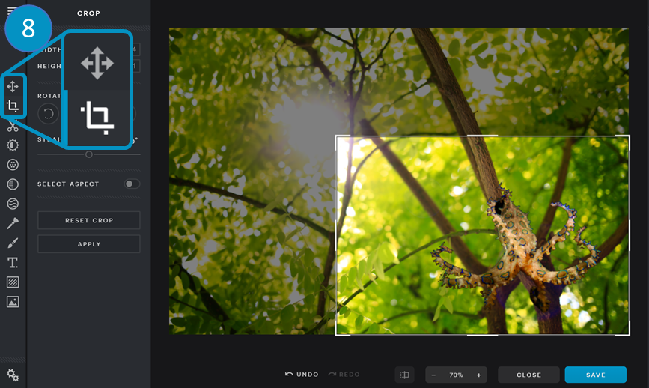
Step 7. Use the ‘Draw Cutout’ tool in ‘Keep’ mode to clean up the image. | Step 8: Use the ‘Arrange’ and ‘Crop’ tools to adjust and resize the image.

