tin can tap

In this tutorial, you will learn how to build an awesome game where you have to tap a tin can to prevent it from falling to the ground.

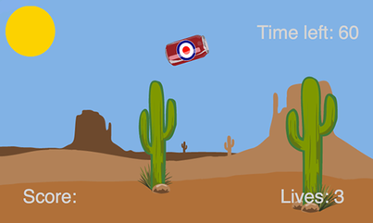

getting started

First you need visit:

https://www.touchdevelop.com/jveh

If you have a Microsoft account, you will be able to login. You can create an account for yourself or use the app without logging in.

using the tutorial

Click the tutorial button

Follow the instructions step by step. Make sure you read the information that appears between each step so that you gain an understanding of what the code is doing (You will need to write your own instructions later).

remembering instructions

Write the result of each instruction below so that you can use them later when customizing your app:

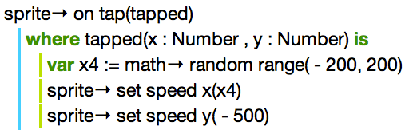

the challenge

Using what you have learnt:

- change the number of points a player receives every time they tap the can
- increase the speed of the tin can after every 10 seconds or add a second tin can when a player reaches 200 points.
- customize your game by changing the background image and adding your own sprites e.g. a Soccer / Football instead of a tin can

