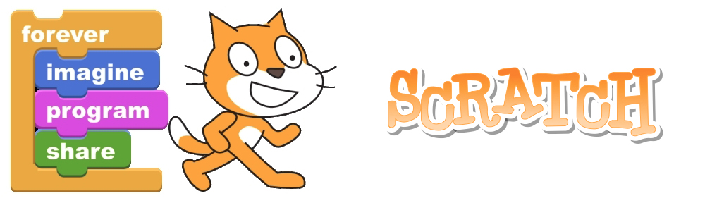

Introduction to Scratch

What is Scratch?

Scratch is a control program that enables you to create your own interactive stories, animations, games, music, and art

The name Scratch comes from the scratching technique used by hip-hop disc jockeys, who spin vinyl records back and forth with their hands to mix music clips together in creative ways. You can do something similar with Scratch, mixing different types of media clips (graphics, photos, music, sounds) in creative ways.

Part 1: Creating your first game – Cat & Mouse

In this introductory tutorial, you will create a simple game in which your character (cat) will follow your mouse pointer around the screen.

1. First let’s change our character.
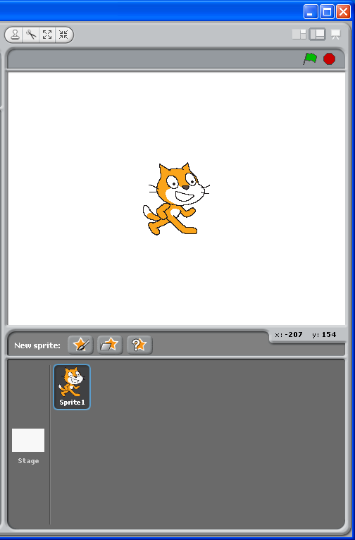

This is sprite1, it comes already loaded in the SPRITE LIST and has already been placed on the STAGE
1: Right Click and delete sprite1 from the SPRITE LIST

2: Click on the insert new sprite button.

3: Select the sprite called cat2 from the animals folder.

4: Rename the sprite and call it cat. Remember to always call new sprites sensible names!

5: From the control menu, drag and drop this rule into the SCRIPTS AREA

Compatible rules can be joined together in the SCRIPTS AREA
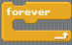
6: From the control menu, drag and drop the forever rule into the SCRIPTS AREA and join it together.

7: From the motion menu, drag and drop the point towards rule into the SCRIPTS AREA and join it inside the forever rule

11: run your program by pressing the green flag.
10: change number of steps to 3.
8: choose mouse pointer from the drop down list.
9: From the motion menu, drag and drop the move 10 steps rule into the SCRIPTS AREA and join it underneath the point towards rule.
Part 2: Controlling your character

In this tutorial, you will learn how to control a sprite using the keyboard.
1: Click on File and New to create a new project.

2: Click on the insert new sprite button.

4: Rename the sprite and call it crab. Remember to always call new sprites sensible names!
3: Select the sprite called crab1-a from the animals folder.

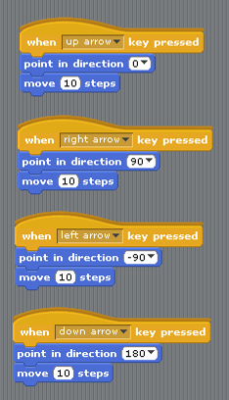
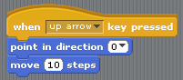
6: Build and test the following script for the crab sprite.
Add a further 3 scripts to make the crab move in all four directions.
5: click the only face left-right button

