Classroom Setup Guide
Preparation
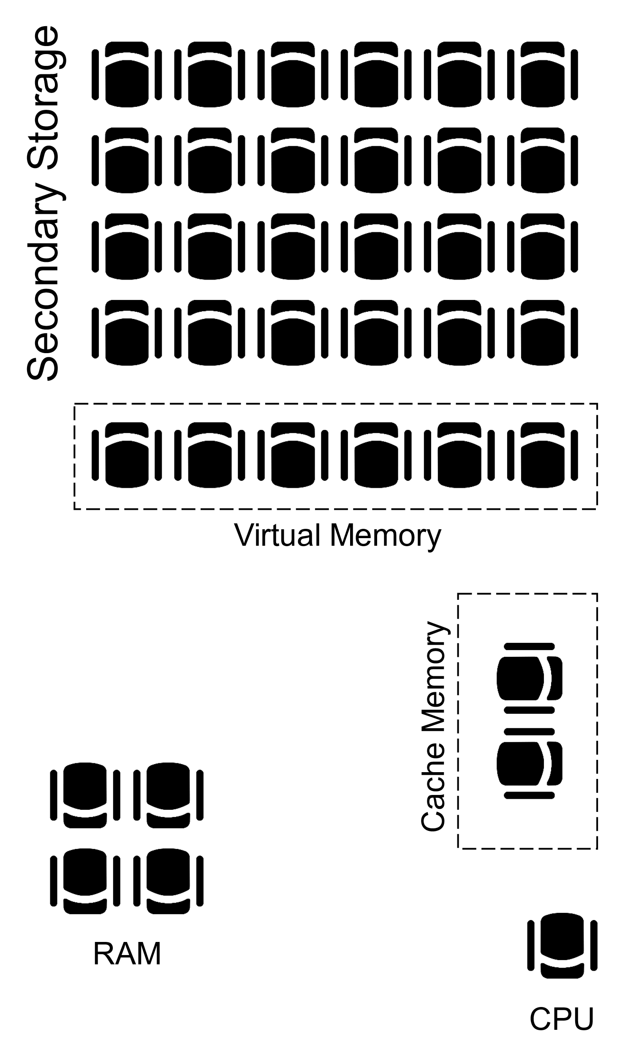
Prior to the lesson, tape off the room (using masking tape, or chalk if delivering the activity outside) to create five separate zones. Prepare and label each of the zones as follows:
- Secondary storage: four rows of five chairs placed near the back of the room.
- Virtual memory: one row of five chairs placed directly in front of the four rows (secondary storage).
- CPU: single chair placed at the front of the room.
- Cache memory: two chairs placed next to the CPU.
- RAM: four chairs placed somewhere between the CPU and virtual memory.

Set-up
Give each student a number at random and ask them to sit in any of the four rows of chairs (secondary storage). Choose one student to take on the role of the CPU and three students to be the ‘buses’ – one who must walk slowly (pigeon steps), one who must walk at a medium pace and one who must move very quickly.

