Representing Data – Infographics
Look at the following example infographics and say which one is better and why.
B
A
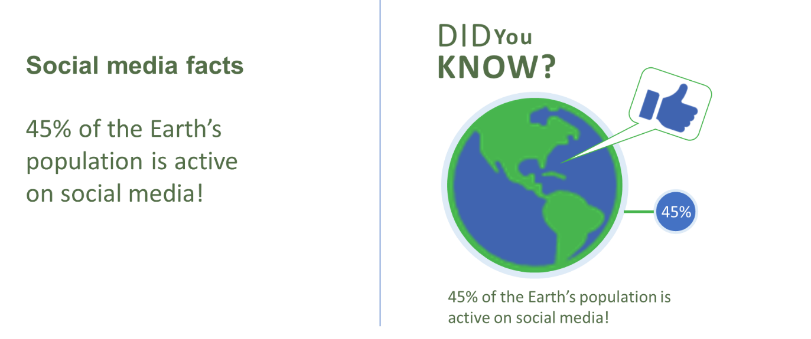
___________________________________________________________________
___________________________________________________________________
___________________________________________________________________
B
A

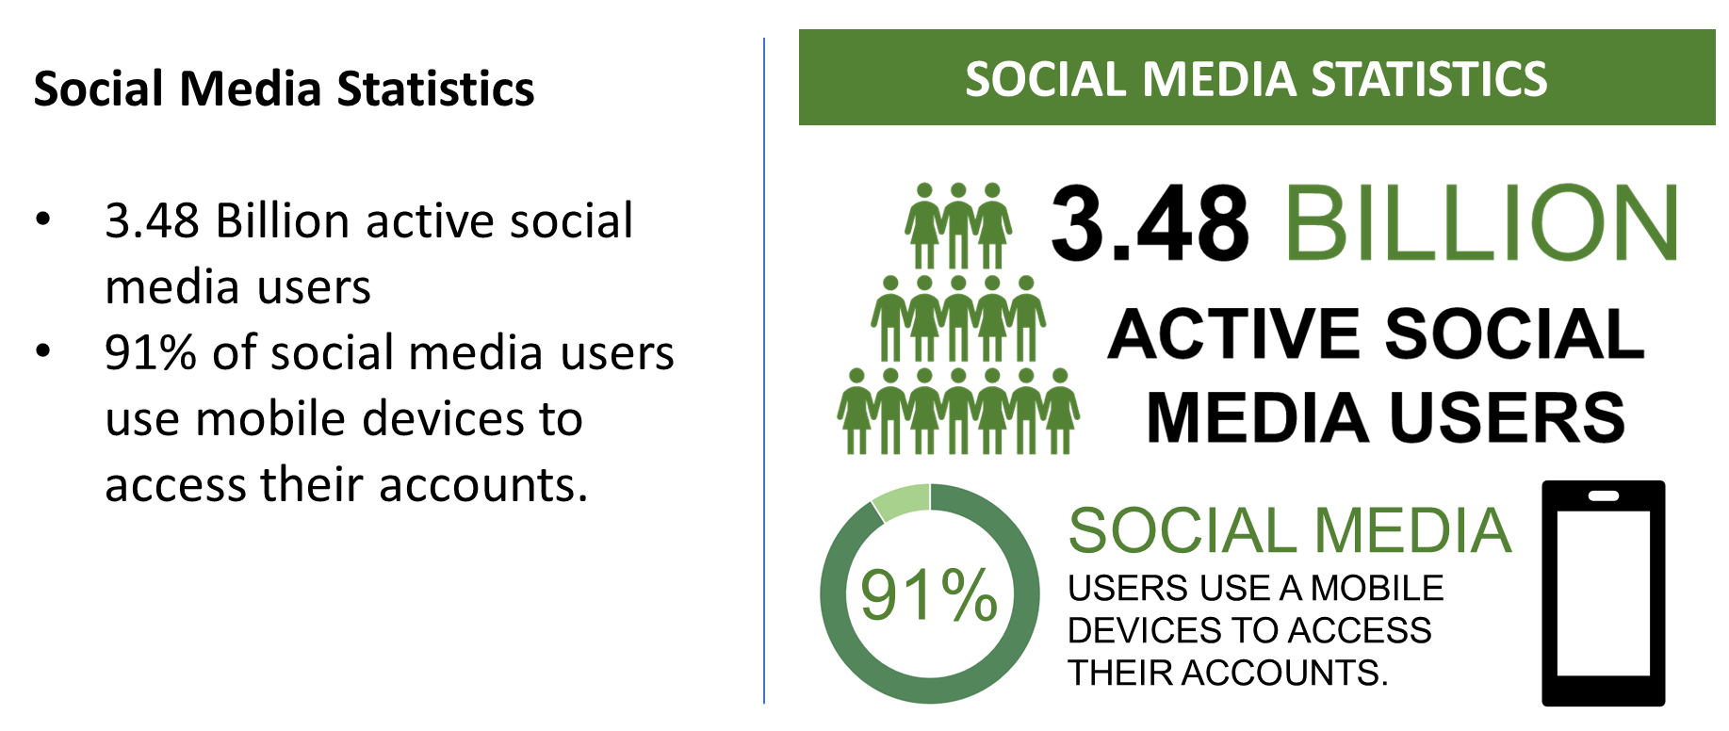
___________________________________________________________________
___________________________________________________________________
___________________________________________________________________

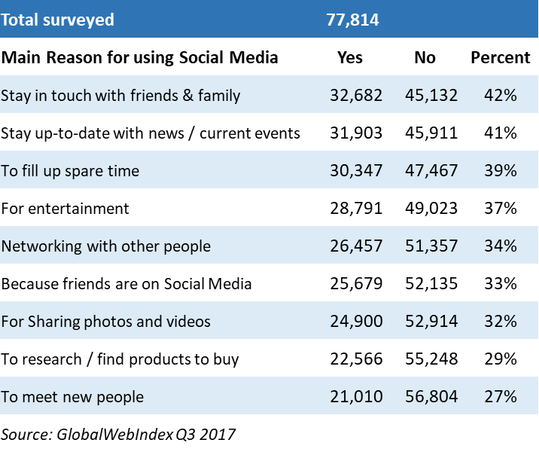
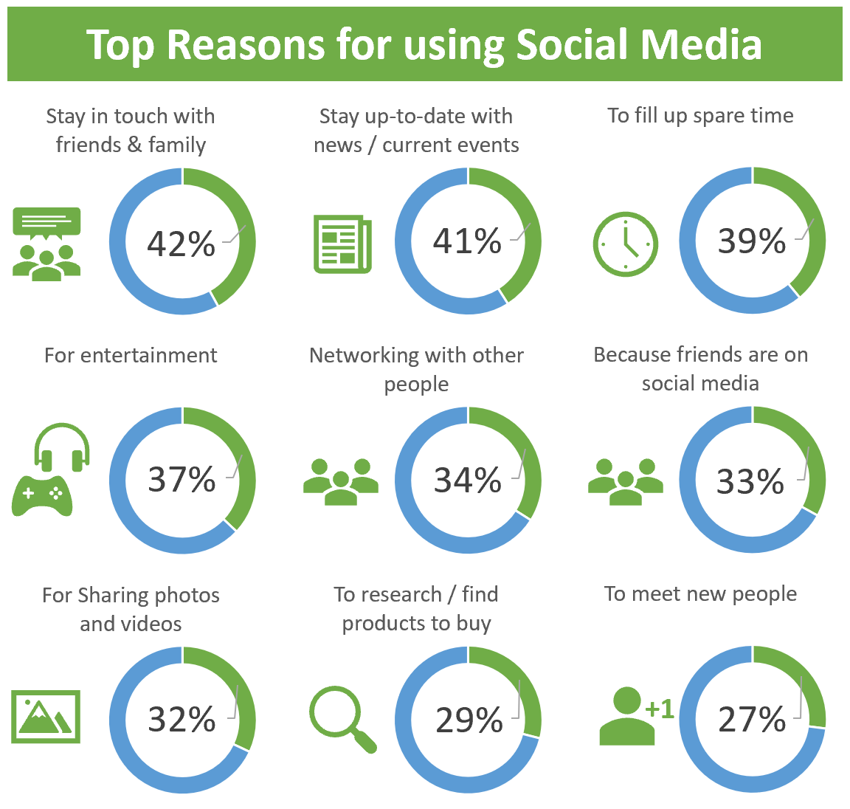
B
A
___________________________________________________________________
___________________________________________________________________
___________________________________________________________________
A
B





