GCSE Computing – End of Topic Test Topic 2 – Binary Representation

1 Data stored in computers can be measured in bits, bytes and kilobytes.

(a) State what is meant by

(i) a nibble

......................................................................................................................................

.................................................................................................................................. [1]

(ii) a byte

.......................................................................................................................................

...................................................................................................................................[1]

(b) A file contains 2048 bytes. Calculate the size of the file in kilobytes.

................................................................................................................................................

................................................................................................................................................

............................................................................................................................................[1]

2
(a) Calculate the denary value of the 8-bit binary number 1001 0111. You must show your working.

.....................................................................................................................................................

.....................................................................................................................................................

.....................................................................................................................................................

................................................................................................................................................. [2]
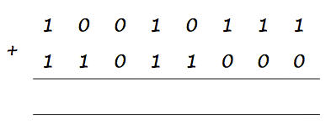
(b) Add the following two 8-bit binary numbers and explain the result. You must show your working.
......................................................................................................................................................
.................................................................................................................................................. [3]

3

(a) Convert the denary number 108 into an 8 bit binary number.

.....................................................................................................................................................

.....................................................................................................................................................

.....................................................................................................................................................

................................................................................................................................................. [2]
(b) Convert the denary number 108 into Hexadecimal.
.....................................................................................................................................................

.....................................................................................................................................................

.....................................................................................................................................................

................................................................................................................................................. [2]

(c) Convert the hexadecimal number 6C to denary. You must show your working.

.....................................................................................................................................................

.....................................................................................................................................................

.....................................................................................................................................................

................................................................................................................................................. [2]
(d) Convert the hexadecimal number 6C to binary. You must show your working.
.....................................................................................................................................................

.....................................................................................................................................................

.....................................................................................................................................................

................................................................................................................................................. [2]

(e) Convert the binary number 00111101 to hexadecimal. You must show your working.
.....................................................................................................................................................

.....................................................................................................................................................

.....................................................................................................................................................

................................................................................................................................................. [2]

(f) Explain why hexadecimal numbers are often used to represent binary numbers.
.....................................................................................................................................................

.....................................................................................................................................................

.....................................................................................................................................................

................................................................................................................................................. [2]

4

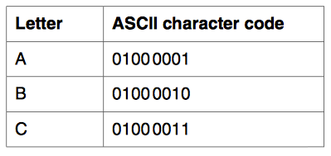
- In the ASCII character set, the character codes for the first three capital letters are given below.

(i) Explain how ASCII is used to represent text in a computer system.

.....................................................................................................................................................

.....................................................................................................................................................

................................................................................................................................................. [1]
(ii) Convert the word CAB into binary using the ASCII character set.
.....................................................................................................................................................

.....................................................................................................................................................

................................................................................................................................................. [1]

- State what is meant by the character set of a computer.
.................................................................................................................................................

............................................................................................................................................. [1]

- Explain why the ASCII character set is not suitable for representing text in all the languages in the world.
.................................................................................................................................................

............................................................................................................................................. [2]

(d) Unicode is also used to represent text in a computer system. Explain the difference between the character sets of Unicode and ASCII.

.....................................................................................................................................................

.....................................................................................................................................................

.....................................................................................................................................................

................................................................................................................................................. [2]

5 Peter takes a high resolution picture with a digital camera. The picture is stored in a bitmap file.

- Tick one box in each row to show whether or not each of the following items must be included in the bitmap file.
 | Must be included | Need not be included
The names of the people in the picture
The width of the picture in pixels
The number of bits used for each pixel
The number of people in the picture
The colour of each pixel

[5]

(b) What is meant by the resolution of the picture?

.................................................................................................................................................

............................................................................................................................................. [1]

(c) How does the resolution affect the size of the bitmap file?

.....................................................................................................................................................

.....................................................................................................................................................

.....................................................................................................................................................

................................................................................................................................................. [2]

6 The memory of a computer contains data and instructions in binary.

(a) Explain why computers use binary.

.................................................................................................................................................

............................................................................................................................................. [2]

(b) Describe how instructions are stored in binary.

.....................................................................................................................................................

.....................................................................................................................................................

.....................................................................................................................................................

................................................................................................................................................. [3]
7 An artist is recording sound using a computer. The graph below represents the pressure wave of the sound being recorded.

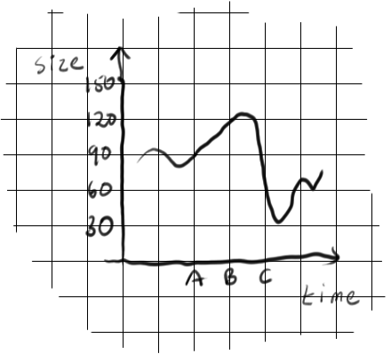

(a) At point A on the graph, the size of the sound wave is 90. This is stored digitally using the binary value of 0101 1010 (or 5A in Hex).

Complete the table below to show how points B and C are stored:

 | Point A | Point B | Point C
Size | 90
Binary Value | 0101 1010
Hex Value | 5A

[6]

(b) Explain how sampling intervals and compression can affect the size of a sound file and the quality of its playback.

The quality of written communication will be assessed in your answer to this question.

........................................................................................................................................

........................................................................................................................................

........................................................................................................................................

........................................................................................................................................

........................................................................................................................................

........................................................................................................................................

........................................................................................................................................

........................................................................................................................................

........................................................................................................................................

........................................................................................................................................

........................................................................................................................................

........................................................................................................................................

........................................................................................................................................

........................................................................................................................................

........................................................................................................................................

........................................................................................................................................

................................................................................................................................... [ 8 ]

