Calculating the exterior angles of regular polygons.

Working out the angles –Regular polygons.
For any polygon, the sum of its exterior angles is 360°. Therefore, we can work out the turning angle for regular polygons
using the following formula: Exterior angle = 360 / No. of sides
For example, to work out the angle to turn for the triangle we need to divide 360 degrees by 3.

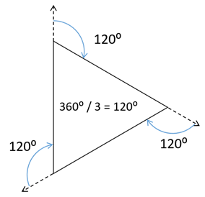
To work out the angles for a pentagon, we need to divide 360 degrees by 5.
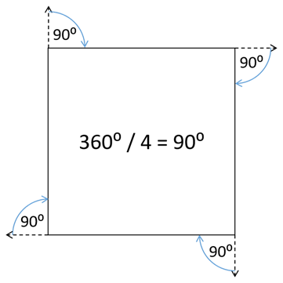
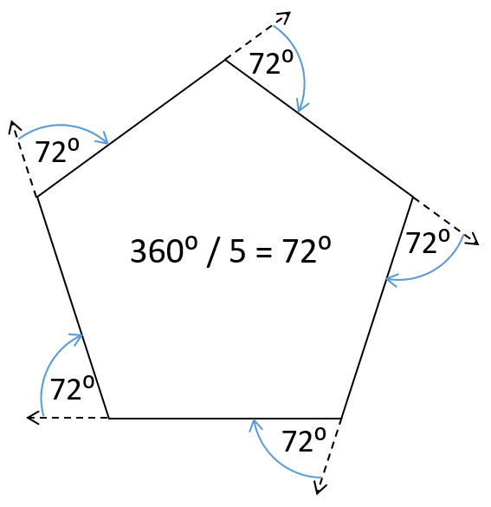
To work out the angles for a square, we need to divide 360 degrees by 4.
Calculating the exterior angles of regular polygons.
Working out the angles – Regular Star polygons.
At the centre of every regular star polygon is a regular polygon. Once we know the angles for the regular polygon, we can work out the angles for the star polygon. See example below:
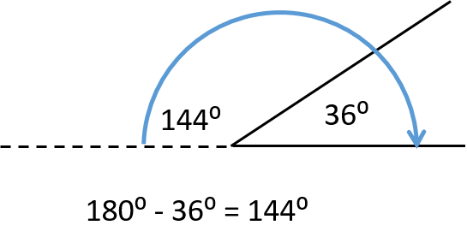
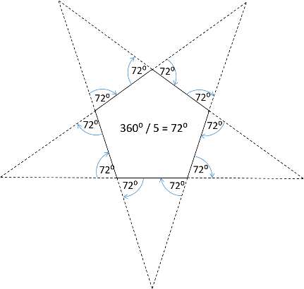
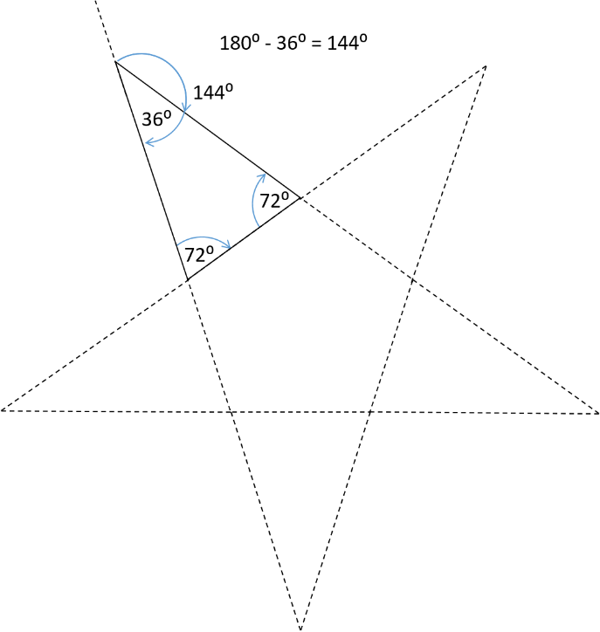
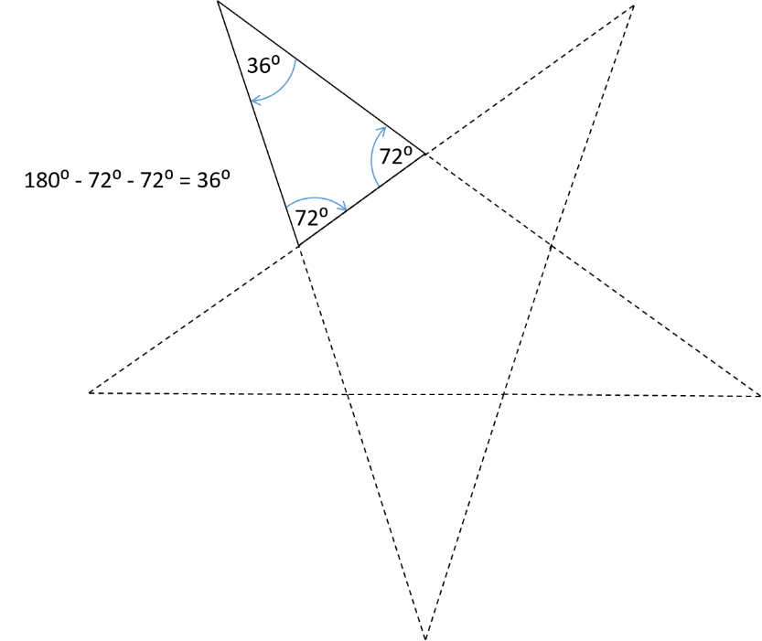
3. The interior and exterior angles add up to 180⁰. As we now know the interior angles of the triangle, we can work out the exterior angle by subtracting the interior angle from 180.
2. The total of all angles inside a triangle add up to 180⁰. As we already know the other two angles, we can now work out the third angle by subtracting the two known angles from 180.
1. At the centre of a pentagram is a pentagon. We already know the exterior angles of a pentagon from the previous task. Using this data, we can work out the rest of the angles.

