 | 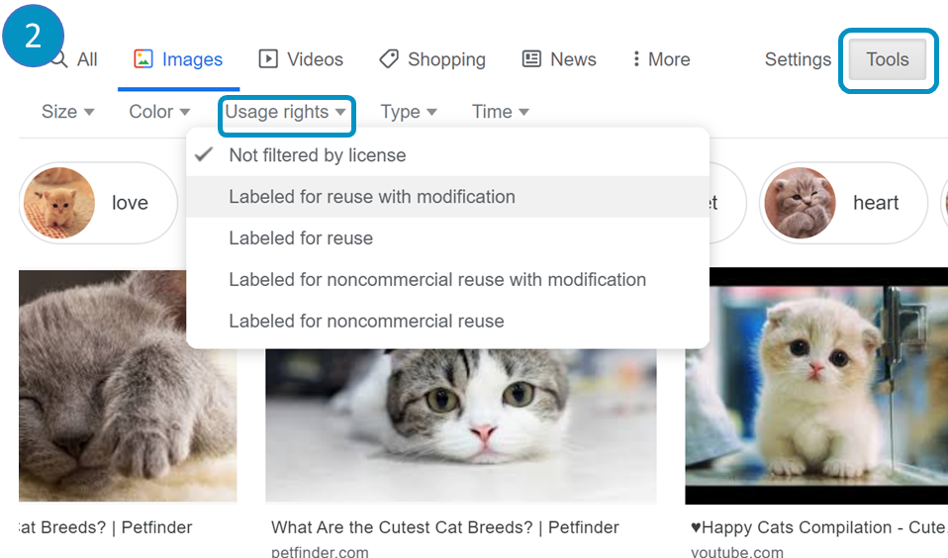
Google: Visit ‘google.com/images’ and enter your search criteria. | Google: Click on ‘Tools’ and ‘User rights’. Tick the option you want.
 | 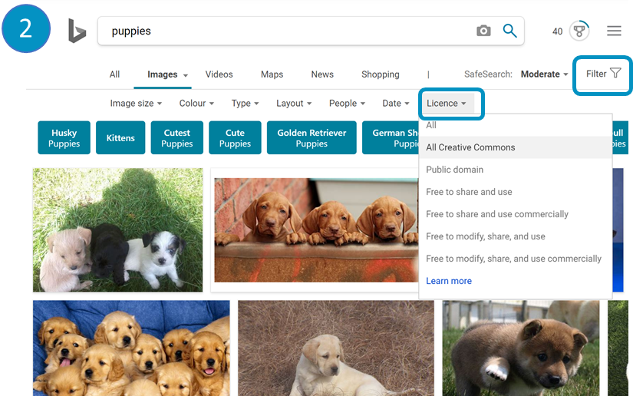
Bing: Visit ‘bing.com/images’ and enter your search criteria. | Bing: Click on ‘Filter’ and ‘Licence’. Select the option you want.
How to search for images labelled for ‘reuse’

